**Chapter 1**

**Introduction**

**1.1 Introduction of our project**

 An online book store is a virtual store on the Internet where customers can browse the catalog and select books of interest. At checkout time, the items in the e-library will be presented as an order. At that time, more information will be needed to complete the request.Usually, the customer will be asked to fill online form. An e- mail notification is sent to thecustomer as soon as the order is placed.This project intends different types of forms with many types of books like story, drama,romance, history, adventures, etc. it can manage studying of books online, customers canchoose many types of books categories, etc. Here, the user may select desired book and viewits price. The user may even search for specific books on the website. Once the user selectsa book, he then has to fill in a form and the book is provided for the user.

**1.2 Problems Statement**

As with most online sites, you need a lot of trust to use online bookstores. The major problemof the online store is that when any sort of network error or power supply cut occurs, thenthe book starts from the beginning. There is no bookmarks as well. There are no properapplication or website to where the students can find study materials for their examinationunder one roof. Students have to search a lot on the web to get complete study materials.[1]

**1.3 Aims and Objectives**

The objective of this project is to develop an e- book store where books can be studied fromthe comfort of home through the Internet.

The Objectives are:

* To read and save the details of book and its author’s name.
* To provide an essence of online book store via simple and yet powerful medium.
* View books of all categories.
* Economical, quick and time convenient.



**1.4 Scope and Motivation**

 Online book store is a convenient way to study books and get updated of new books with the features of cost savings, recommendations and feedback.

The main motive behind the project is to provide facilities that can be available in online bookstore.

Our effort here is to allow people to overcome costly books.

**1.5 Application and Feasibility**

Most of the people, these days are connected with technology and are familiar with it. So,this application is useful to all the website users as they can study all the required books intheir devices using this application.

**Chapter 2**

**Literature Review**

A lot of websites and applications can be found when we search the google which aredeveloped for learning purposes. But there is ambiguity in choosing the appropriate contentin appropriate time. Some websites has been developed which consists of stories, novels,essays etc. Similarly, some personal blogs and websites are developed for studying purpose.Electronic Commerce (e-commerce) applications support the interaction between different parties participating in a commerce transaction via theÂ 24 Sep 2017 Shop new, used, rare,and out-of-print books. literature review for online bookstore. prototype provides a guidelinein developing a real system of Online Ordering Book based on user's perspective, particularly in the perspective of academic will be handled by the university's book store.However, the ordering is still done manually. Based on literature reviews and web sitereviews of other universitiesÂ. This research was undertaken to provide background for theSCONUL and Jisc eBook Co-Design Project. Since the 1980's, when e-books firstÂ Theidea of this review paper, begins from writer's disappointment about online bookstore servicequality in. Indonesia. Which is, as a consumer in several transactions with the online bookstore. In overall, the writer's did not satisfied towards their services. Lions VillaProbation Hostel Gate Pass Management System at Coimbatore Campus AmritaThecomputerized Gate Pass Management SystemÂ 27 Sep 2017. Also includes introduction tometa-analysis. Relevant to students from any discipline. Includes contributions from both a professor and a librarian.[2]

**Chapter 3**

**System Design**

System design represent the overall concept on how the system works. In our system there aretwo modules. They are system module and admin module.

User Module

* Only register user can login into the application.
* Those users who are not register must register first by filling the necessary attributes such asname, email, password etc. and then the account will be created by providing user name and password.
* User can read the contents of the application such as notes, books, syllabus etc.
* User can watch the videos available in application.
* Interested users can also suggest and provide study materials to admin.

Admin Module

* Admin can upload the study materials such as notes, books, syllabus, old question collection etc.
* Admin can check, verify and post the study materials that are provided by the user.

The overall system can be represented by using following block diagram:

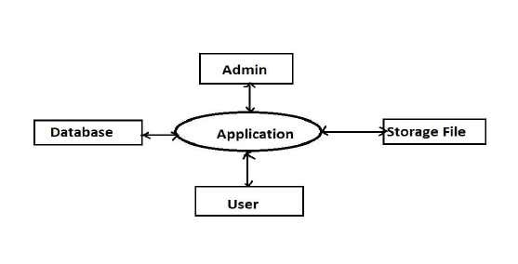

 11

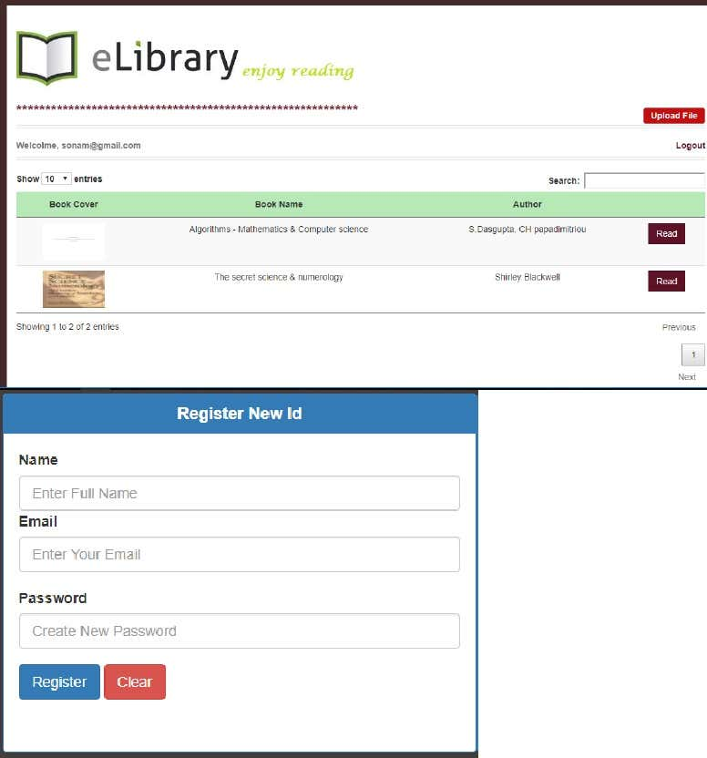

 12

**Chapter 7Conclusion, limitations and future work**

“Website design is like a shop

Interior. If the shop looks poor or like hundreds of other shopsthe customer is most likel

y to skip to the other site”

. Hence we have designed the project to provide the user with easy navigation, retrieval of data and necessary feedback as much as possible.

It is convenient for the customer to view the contents of books. The Online Book StoreApplication described in this project provides a number of features that are designed to makethe customer more comfortable.The limitations are:-

Cannot be used without internet.-

Users cannot give feedbacks.-

Limited books are only available.-

Error in spelling by the user cannot provide the exact book they want.The future scope for our project can be:

-

Purchase books online

-

Publishers insolvency

 13

**Chapter 8References**

[1]

“Engineering paathshala.” .

 [2]

E. S. Rn and M. C. Rn, “Literature review,”

*International Journal of Nursing Practice*

. pp. 89

 –

98, 2002.[3]

“E

-Book-

Wikipedia.”

.[4]

A. Techniques, “Contents 1,” pp. 1–

26.

 14